
RAMAIAH
INSTITUTE OF TECHNOLOGY
USN | 1 | M | S

(Autonomous Institute, Affiliated to VTU)
Bangalore – 560 054

SEMESTER END EXAMINATIONS – JANUARY 2017

Course & Branch | : | Electrical & Electronics Engineering. | Semester | : | V
Subject | : | Control Systems | Max. Marks | : | 100
Subject Code | : | EE502 | Duration | : | 3 Hrs

Instructions to the Candidates:
- Answer one full question from each unit.

 |  | UNIT-I
1. | a) | What is the significance of presence of feedback in control system? Explain with at least two example. | CO1 | (06)
 | b) | Define transfer function? And Briefly explain the need for modeling of a system. | CO1 | (06)
 | c) | Obtain the transfer function 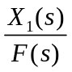 of the following system  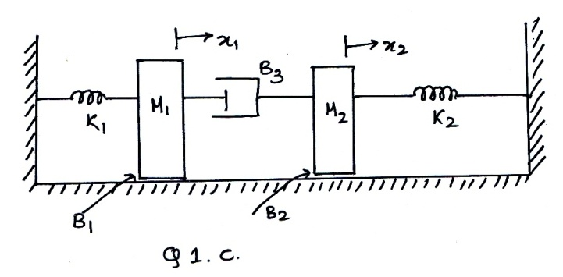  →f(t) | CO1 | (08)
2 | a) | Obtain the i) Force - current analogy ii) Force – Voltage analogy of the following mechanical system.  motor.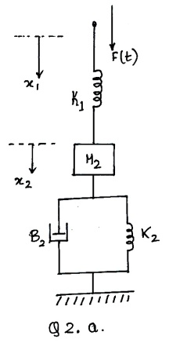 | CO1 | (12)
 | b) | Derive transfer function of armature controlled separately excited DC servo motor. | CO1 | (08)
 |  | UNIT-II
3. | a) | Obtain the transfer function using Mason’s gain reduction formula for fig shown in 3a) .  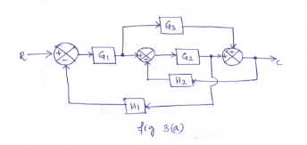 | CO2 | (08)
 | b) | The closed loop transfer function of a second order system is given by T(s)=25/(S²+6S+25). Determine the damping ratio, natural frequency of oscillations, rise time, settling time and peak overshoot if subjected to unit step input. Also calculate expression for it’s output response. | CO2 | (08)
 | c) | For a system G(s)H(s)=K/[S²(S+2)(S+3)]. Find the value of K to limit steady state error to 10, when input to system is 1+10t+(40/2)t². | CO2 | (04)
4. | a) | Find the C/R using block diagram reduction technique of the system shown in fig 4a) also verify using signal flow graph.  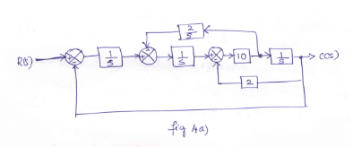 | CO2 | (10)
 | b) | Open loop transfer function of unity feedback system is G(S)=K/[(1+TS)S] ,where K and T are constants. Determine factor by which gain ‘K’ should be multiplied so that overshoot of unit step response be reduced from 75% to 25%. | CO2 | (10)
 |  | UNIT-III
5. | a) | A negative unity feedback system is having OLTF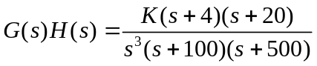. Find the range of K from RH criterion for which system stable. | CO3 | (08)
 | b) | A system having OLTF 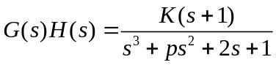, oscillates with frequency 2 rad/sec. Find values of ‘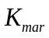’and ‘p’ if system is stable. | CO3 | (12)
6. | a) | Plot the root locus of the system with OLTF 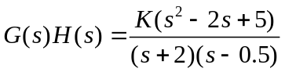. | CO3 | (10)
 | b) | The closed loop TF of positional control system is given by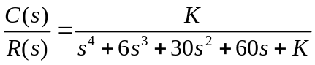.  Determine, i) The range of K for which system is stable.  ii) What should be the upper limit and lower limit of K if all the closed loop poles are required to be to the left of line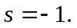 | CO3 | (10)
 |  | UNIT-IV
7. | a) | Using Nyquist stability criterion, investigate the closed loop stability of a negative feedback control system whose open loop transfer function is given by G(S)H(S)=100(1+5s)/[s⁴(s+1)]. | CO4 | (12)
 | b) | Consider G(S)H(S)=1/[s(1+T₁s)(1+T₂s)]. Draw the polar plot. | CO4 | (08)
8. | a) | Using Nyquist stability criterion, investigate the closed loop stability of a negative feedback control system whose open loop transfer function is given by G(S)H(S)=10/[s(s+1)(s+2)], hence determine the range of value of K for stability. | CO4 | (12)
 | b) | Consider G(S)H(S)=1/[s²(1+T₁s)]. Draw the polar plot. | CO4 | (08)
 |  | UNIT-V
9. | a) | Obtain the transfer function of lag compensator, for 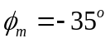and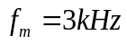. Assume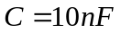. Also find the corner frequencies. | CO5 | (08)
 | b) | Obtain the transfer function of the system whose Bode plot is as shown below.  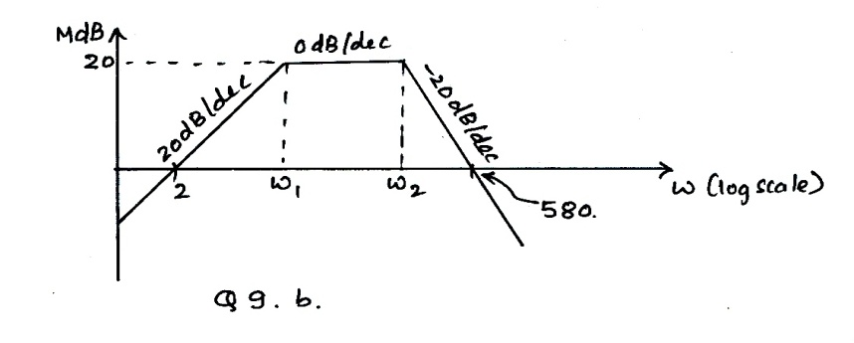 | CO4 | (12)
10. | a) | Obtain the Bode plot of unity negative feedback system, whose OLTF is 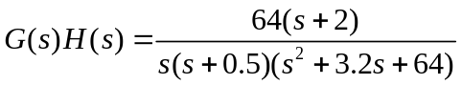 . Hence find the stability of the system. | CO4 | (14)
 | b) | Explain the need for designing of a compensator with one practical example. | CO4 | (06)
****************

